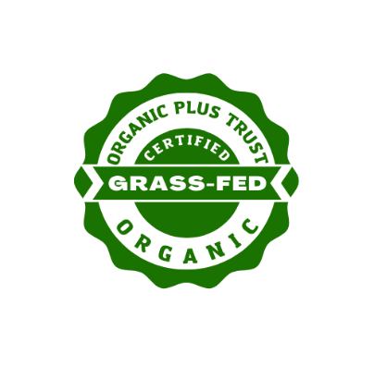

Organic Plus Trust (OPT) Grass-Fed Organic Certification

Uniform Certification Program Application for Handling

[**By submitting this application, you agree to the most current OPT Grass-Fed Certification Program Manual and Standard.**](https://organicplustrust.com/program-materials)

You must be able to affirm the below information and answer all questions in this application.

* Current and in good standing Handling certification to the USDA-National Organic Program (NOP).

|  |
| --- |
| **OPERATION INFORMATION** |
| 1. Operation Name (must match exact name on organic certificate) |
| 1. Main Contact   Title: ______________________________________  Name: ____________________________________  Phone: ____________________________________  Email: _____________________________________  Preferred Method of Contact: ☐ Email ☐ Phone ☐ Postal Mail |
| 1. Additional Contact   Title: _____________________________________  Name: ____________________________________  Phone: ____________________________________  Email: ____________________________________  Preferred Method of Contact: ☐ Email ☐ Phone ☐ Postal Mail |
| 1. Mailing Address   Street: __________________________________  City: ____________________________________  State: ___________________________________  Zip: _____________________________________ |
| 1. Main Physical Address ☐ Same as mailing   Street: ___________________________________  City: _____________________________________  State: ____________________________________  Zip: ______________________________________ |
| 1. Additional Location A:   Street: ____________________________________  City: ______________________________________  State: _____________________________________  Zip: _______________________________________ |
| 1. Additional Location B: (Additional locations use separate attachment)   Street: ___________________________________  City: _____________________________________  State: ____________________________________  Zip: ______________________________________ |
| 1. Have you ever been certified in the OPT Grass-Fed program? ☐ Yes, *please list below* ☐ No |
| 1. Estimated date you need to be certified by: |
| 1. What type of Agricultural Ingredients will you be processing? *check all that apply*   ☐ Cattle  ☐ Milk ☐ Meat  ☐ Sheep  ☐ Milk ☐ Meat  ☐ Goats  ☐ Milk ☐ Meat  ☐ Bison  ☐ Meat  ☐ Other, list __________________________________________________________________ |
| 1. Specific Products: *check all that apply*   ☐ Fluid Milk ☐ Cream ☐ Kefir ☐ Ghee ☐ Anhydrous Milk Fat  ☐ Powdered Milk ☐ Cheese ☐ Butter ☐ Clarified Butter ☐ Yogurt  ☐ Primal Cuts  ☐ Sausage  ☐ Other, list __________________________________________________________________ |
| 1. Are you using copackers or processing under private labels? |

|  |
| --- |
| **COMPOSITION AND LABELING OF OPT GRASS-FED CERTIFIED PRODUCTS** |
| *Section XI – Labeling*  *Section XII – Mandatory Use of this Program’s Seal* |
| 1. List the products you intend to package in a retail and nonretail label or container that will incorporate the OPT Grassfed seal.[1] *Attached separate list if needed.*  |  |  |  |  | | --- | --- | --- | --- | | **Product Name** | **Brand Name** | **Retail or Nonretail?** | **List OPT Certified Ingredients** | |  |  |  |  | |  |  |  |  | |  |  |  |  | |  |  |  |  | |  |  |  |  | |  |  |  |  | |  |  |  |  | |
| 1. List all OPT Certified ingredient supplier(s) or attach a separate sheet if needed.  |  | | --- | | **Supplier Name** | |  | |  | |  | |  | |  | |  | |

|  |
| --- |
| **RECORDKEEPING AND SEGREGATION** |
| *Standards section IX - Production and Handling Operations* |
| 1. Do you maintain and possess current records demonstrating the Handling of products that are intended to be sold, Labeled, or represented as “Certified Grass-Fed Organic” are in full compliance with this Standard?  * Yes * No |
| 1. Will you be Producing and/or Handling Parallel products not certified to this standard?  * Yes List non-certified processed products and production type. ____________________________________________________________________________________________________________________________________________________________________________________________________________________________________________________________________________________________________________________________________   Explain your plan to ensure how non-certified processed products will be segregated from OPT Certified products and prevent non-certified products from being sold, Labeled or represented as OPT Certified.  __________________________________________________________________________  __________________________________________________________________________  __________________________________________________________________________   * No, all processed products will be certified OPT Grass-Fed. |
| 1. What is your method of tracking OPT Grass-Fed certified ingredients from source to sale of final? *Submit a sample of your recordkeeping system used products including your lot numbering system.*   __________________________________________________________________________  __________________________________________________________________________  __________________________________________________________________________ |

1. Section XII Mandatory use of this program’s seal. Agricultural products in packages described in the NOP at 7 C.F.R. §205.301 and §205.307 shall bear the seal of this Program (“OPT Grass-Fed Organic Seal”) OPT will follow up with a License agreement for the use of the OPT Grass-Fed Organic Seal. Use of the seal and a License Agreement with OPT is required for use on all consumer facing labels.