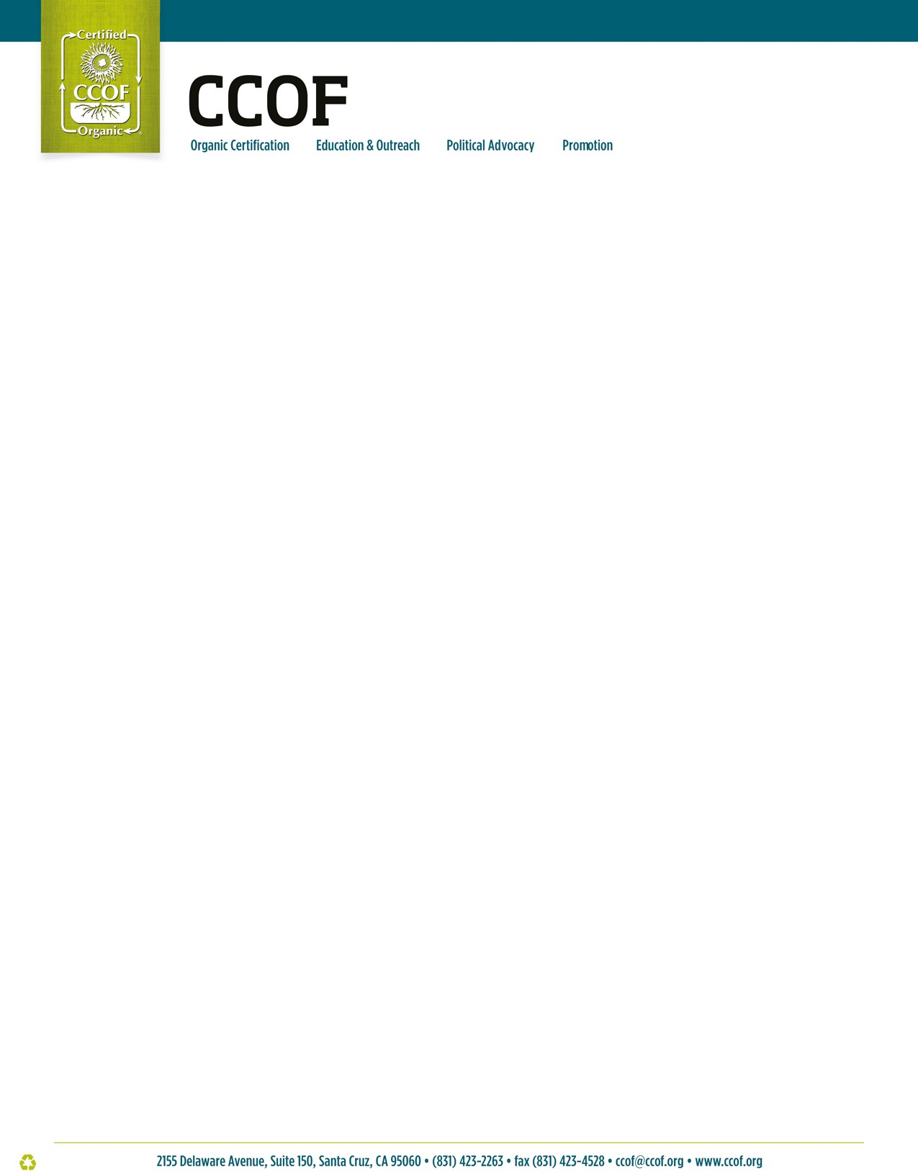

Animal Transport Affidavit

* Use this affidavit to affirm that all organic animal transport requirements are met.
* Though transportation does not require certification, organic livestock operations are responsible for maintaining complete transportation records for their animals. Operations must also demonstrate prevention of commingling and contamination during transport, & fully describe the transport practices in their OSP (if overseeing the transportation.).
* Maintain one affidavit per shipment of livestock.

**Transportation Service Provider Information**

|  |  |
| --- | --- |
| Name of transportation business |  |
| Transporters full name |  |
| Date and time of animal pickup |  |
| Name of certified operation where animals are being picked up |  |
| Physical address of animal pickup |  |
| Date and time of animal drop-off |  |
| Name of certified operation where animals are being dropped off |  |
| Physical address of animal drop-off |  |
| Total duration of animal transport (from when all animals are loaded until the vehicle arrives at its final destination) |  |

**Livestock Information**

|  |  |
| --- | --- |
| Name of certified livestock operation |  |
| Livestock owner full name |  |
| Type(s) of animals being transported | Ruminant animals: Attach list of animals and their organic status, including organic slaughter eligibility status, with this affidavit.  Avian species. Animals are identified as organic as described and approved in my OSP. |
| Quantity of animals being transported |  |
| Reason for transport |  |

**Transportation Attestation**

* The operations responsible for each of the requirements below are to initial their name in the applicable column:

|  |  |  |  |
| --- | --- | --- | --- |
| **Requirement** | **Notes / Applicability** | **Responsibility of Livestock Owner (Initials)** | **Responsibility of Transporter (Initials)** |
| Transportation vehicle was thoroughly cleaned prior to loading animals ensuring no risk of contamination e.g., consuming remnants of nonorganic feed. |  |  |  |
| All livestock are fit for transport to buyers, auction or slaughter facilities. |  |  |  |
| Certified organic livestock are clearly identified as organic, and this identity is made traceable for the duration of transport. |  |  |  |

*NOPB110, V1, 6/17/2024 Page* ***1*** *of* ***2***



|  |  |  |  |
| --- | --- | --- | --- |
| **Requirement** | **Notes / Applicability** | **Responsibility of Livestock Owner (Initials)** | **Responsibility of Transporter (Initials)** |
| Calves have a dry navel cord and are able to stand and walk without human assistance. | N/A. Not transporting calves. |  |  |
| Seriously crippled and non-ambulatory animals are not being transported for sale or slaughter. |  |  |  |
| Adequate and season-appropriate ventilation is provided for all livestock trailers, shipping containers, and any other mode of transportation used to protect animals against cold and heat stresses. |  |  |  |
| During any transport and prior to slaughter, bedding is provided on trailer floors and in holding pens, as needed, to keep livestock clean, dry, and comfortable. Use of bedding must be appropriate to the species and type of transport. | N/A. Poultry crates |  |  |
| If transport exceeds eight hours, measured from the time all animals are loaded onto a vehicle until the vehicle arrives at its final destination, organic management and animal welfare is maintained in accordance with the livestock operations OSP. | N/A. Not transporting for longer than 8 hours. |  |  |
| Emergency plans are in place that adequately address possible animal welfare problems that might occur during transport (e.g. animal injury, animals escaping, breakdown of vehicle, etc.) |  |  |  |

*By signing this Affidavit, I attest to the accuracy of the transportation arrangement described above. I agree to immediately* notify the livestock owner and CCOF of any issue or emergency that affects the well-being of animals in transport.

# Transportation Service Provider:

*I maintain records of all activities that I perform and ensure copies of those records are provided to the certified livestock* operations.

|  |  |  |
| --- | --- | --- |
| Printed Name | Signature | Date |

# Certified Livestock Operation:

*I maintain records of all activities performed by the service provider and have these records available for auditing at my organic* inspections.

|  |  |  |
| --- | --- | --- |
| Printed Name | Signature | Date |

*The National Organic Standards section 7 CFR 205.201(a) requires that organic livestock must be managed according to an* Organic System Plan (OSP), which is agreed upon by the certifying agent.

*NOPB110, V1, 6/17/2024 Page* ***2*** *of* ***2***